SIMATS ENGINEERING (SAVEETHA SCHOOL OF ENGINEERING)
Department of Artificial Intelligence and Data Science
ASSESSMENT TOOL 1 – ANALYTICAL PROBLEM SOLVING

Course Code: | DSA03 | Course Title: | Natural Language Processing
CO Assessed: | CO2 – Manipulation | Assessment: | Assessment Tool 1 – ANALYTICAL PROBLEM SOLVING
Weightage: | 50% of CIA
CO5 Statement: | Design inflectional, derivational, finite-state parsing, stemming algorithms and for analyse morphological methods. (BL-3)
Student Name: | Y Greeshma Reddy | Reg. No.: | 192424146
Section / Batch: | B Tech-AI&DS | Date: | 01-08-2026

Code of Conduct
I Y Greeshma Reddy (Name / Reg No) certify that this submission is my original work and that I have adhered to the guidelines specified for this assessment. I understand that any violation of academic integrity rules will result in disciplinary action.
Signature of the Student: Y Greeshma Reddy

Instructions
- Read all questions carefully before attempting the answers.
- Answer all five questions. Each question carries equal marks.
- Show all intermediate steps, calculations, probability computations, tagging decisions, and justifications wherever applicable.
- Duration: 30 minutes.

Section / Topic | Focus | Q Nos
English Word Classes, Part of Speech Tagging | Morphological decomposition of connected, connecting, and connection; identification of roots, suffixes, inflectional vs. derivational forms, and normalization for document indexing. | Q1
English Word Classes, Tagsets for English, Rule-Based Part of Speech Tagging | Morphological parsing of unhappy, happiness, and happily; identification of prefixes, suffixes, base forms, and semantic effects of derivational morphology. | Q2
Counting Words, Part of Speech Tagging, English Word Classes | Stemming and root extraction for played, player, and playing; handling grammatical variations and word formation changes for search preprocessing. | Q3
Finite-State Morphological Analysis, Rule-Based Part of Speech Tagging, Transformation-Based Tagging | Finite-state parsing of writes, writing, and written; modeling regular and irregular verb inflections and root normalization. | Q4
English Word Classes, Rule-Based Part of Speech Tagging, Counting Words | Porter Stemmer-based processing of relational, relation, and relate; application of derivational suffix removal and stem extraction for retrieval. | Q5

Annexure A – ANALYTICAL PROBLEM SOLVING
1. Given the input words: “connected”, “connecting”, “connection”, design a morphological analysis pipeline for a document indexing system.
Apply rules to decompose each word into root and suffix components.
Differentiate between inflectional and derivational forms within the dataset.
Normalize all variants to a common base form for efficient retrieval.
Determine the parsed structure and normalized output for each word.

2.Given the input words: “unhappy”, “happiness”, “happily”, design a morphological parsing module for sentiment analysis.
Identify prefixes, suffixes, and base forms using rule-based decomposition.
Ensure semantic consistency across derived word forms.
Classify each transformation as inflectional or derivational.
Produce the root and morphological breakdown for each word.

3. Given the input words: “played”, “player”, “playing”, design a stemming-based preprocessing module for a search engine.
Apply morphological rules to strip affixes and identify the base form.
Handle both grammatical variations and word formation changes.
Ensure consistent root extraction across all forms.
Determine the stem and classification for each input word.

4. Given the input words: “writes”, “writing”, “written”, design a finite-state morphological parsing module for a text processing system.
Apply state transitions to represent suffix transformations and irregular forms in verb inflection.
Differentiate between regular and irregular inflectional patterns within the dataset.
Ensure consistent mapping of all forms to a common root representation.
Determine the state transitions, morphological breakdown, and normalized output for each word.

5. Given the input words: “relational”, “relation”, “relate”, design a Porter Stemmer-based preprocessing module for document retrieval.
Apply stemming rules step-by-step to remove derivational suffixes and obtain base forms.
Handle variations in suffix patterns while preserving semantic consistency.
Ensure uniform root extraction across all derived forms.
Determine the stemming steps, intermediate forms, and final stem for each input word.

Rubrics for Calculation

Numerical Problems
Criteria | Weightage | Level 4 (Exemplary) | Level 3 (Proficient) | Level 2 (Developing) | Level 1 (Beginning)
Problem Understanding | 20% | Clearly interprets problem, identifies all parameters and requirements accurately | Understands problem with minor gaps | Partial understanding; misses key elements | Misinterprets or unable to understand problem
Method Selection | 20% | Selects most appropriate method/formula with strong justification | Selects correct method with minor errors | Inappropriate or partially correct method | Unable to select method
Solution Process | 25% | Logical, systematic steps with correct approach throughout | Mostly correct steps with minor mistakes | Disorganized steps; multiple errors | No clear process
Accuracy of Calculation | 20% | All calculations accurate; correct final answer | Minor calculation errors | Frequent errors; incorrect final answer | No valid calculations
Interpretation of Results | 15% | Clearly interprets results with units and engineering relevance | Basic interpretation with minor omissions | Limited or unclear interpretation | No interpretation

Q. No. / Criteria Level | Problem Understanding | Method Selection | Solution Process | Accuracy of Calculation | Interpretation of Results | Sub. Total | Total %
1
2
3
4
5

Faculty In-charge | Course Coordinator | Program Director
Signature: _______________ | Signature: _______________ | Signature: _______________
Date: ___________________ | Date: ___________________ | Date: ___________________

Q1. Morphological Analysis Pipeline (connected, connecting, connection)

1. Problem Understanding
- Understand the given words: connected, connecting, connection.
- Identify the root word and suffix for each.
- Distinguish between inflectional and derivational forms.
- Normalize all words to the common base form connect for document indexing.
2. Method Selection
- Rule-based Morphological Analysis.
- Suffix stripping.
- Root word identification.
- Lemmatization (normalization).
3. Solution Process
Word | Root | Suffix | Type | Normalized Form
connected | connect | -ed | Inflectional | connect
connecting | connect | -ing | Inflectional | connect
connection | connect | -ion | Derivational | connect

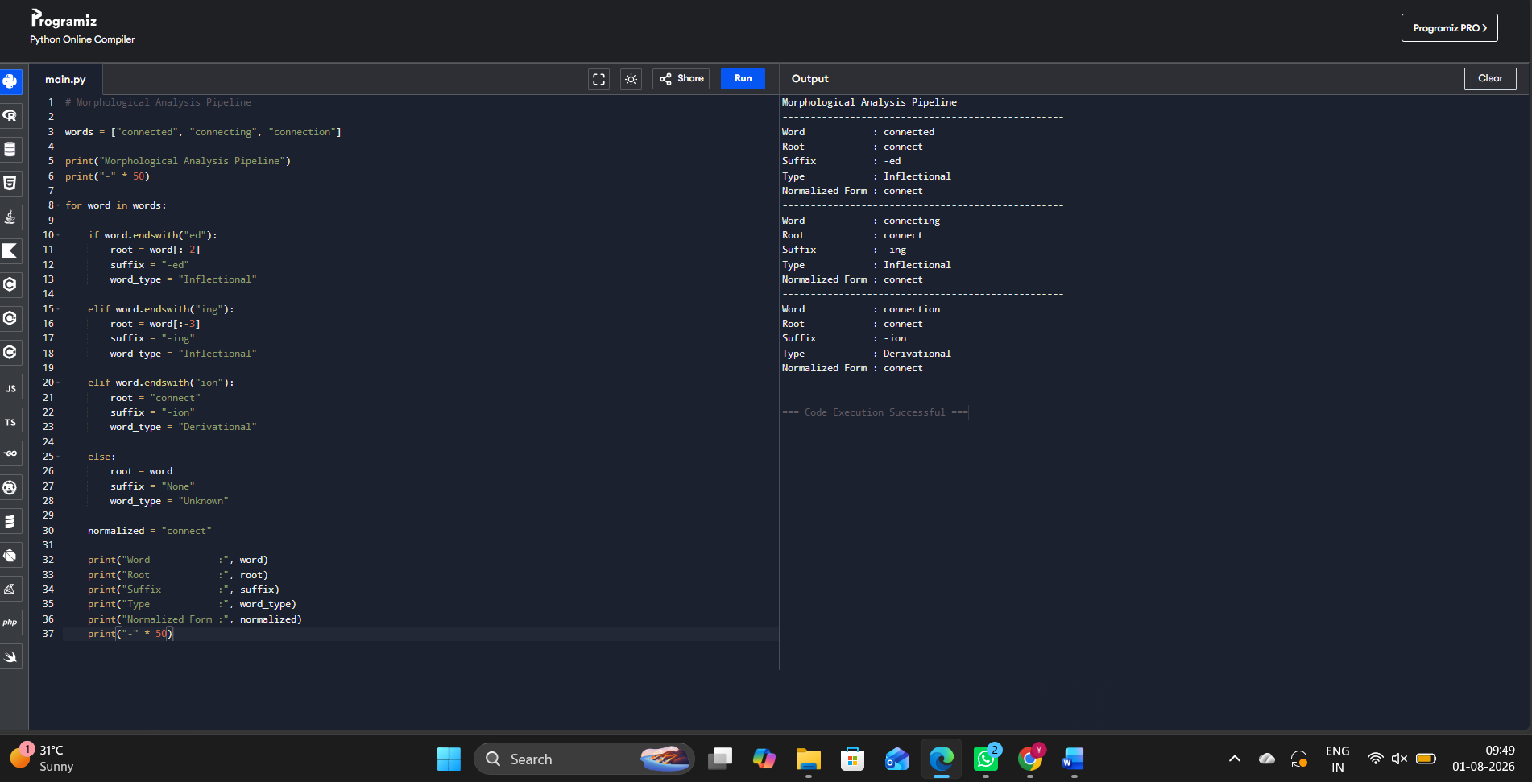

4. Accuracy of Calculation
- All suffixes are correctly identified.
- Inflectional forms preserve grammatical meaning.
- Derivational form creates a noun from the verb.
- Every word is successfully normalized to connect.
5. Interpretation of Results
- Inflectional forms (connected, connecting) only change tense/aspect.
- Derivational form (connection) changes the word class.
- Normalization improves indexing and search efficiency by treating all variants as connect.

Q2. Morphological Parsing (unhappy, happiness, happily)

1. Problem Understanding
- Analyze unhappy, happiness, happily.
- Identify prefixes, suffixes, and root.
- Classify transformations.
- Preserve semantic consistency.
2. Method Selection
- Rule-based morphological parser.
- Prefix and suffix detection.
- Root extraction.
- Morphological classification.
3. Solution Process
Word | Prefix | Root | Suffix | Type
unhappy | un- | happy | — | Derivational
happiness | — | happy | -ness | Derivational
happily | — | happy | -ly | Derivational

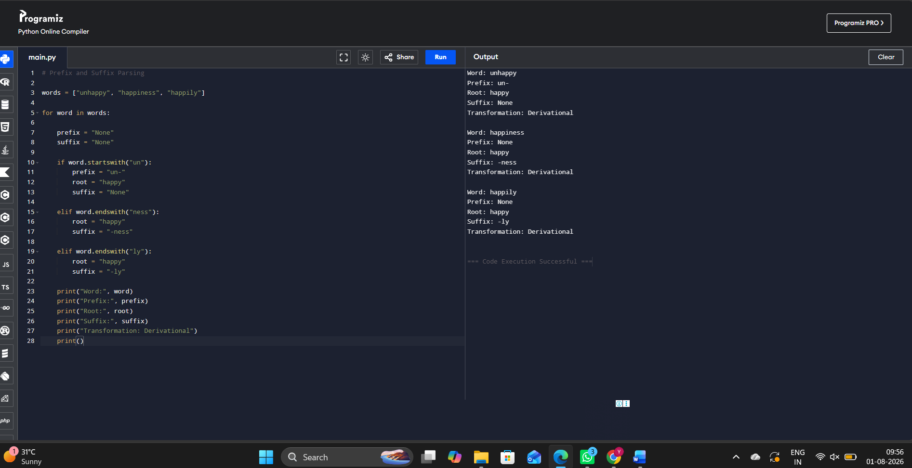

4. Accuracy of Calculation
- Prefix and suffix are correctly detected.
- Root happy is consistently extracted.
- All transformations are correctly classified as derivational.
5. Interpretation of Results
- Prefix un- changes meaning (negative).
- Suffix -ness forms a noun.
- Suffix -ly forms an adverb.
- Common root happy maintains semantic consistency for sentiment analysis.

Q3. Stemming-Based Preprocessing (played, player, playing)

1. Problem Understanding
- Analyze played, player, playing.
- Remove affixes.
- Identify common stem.
- Classify word formation.
2. Method Selection
- Rule-based stemming.
- Affix stripping.
- Root extraction.
- Morphological classification.
3. Solution Process
Word | Removed Affix | Stem | Classification
played | -ed | play | Inflectional
player | -er | play | Derivational
playing | -ing | play | Inflectional

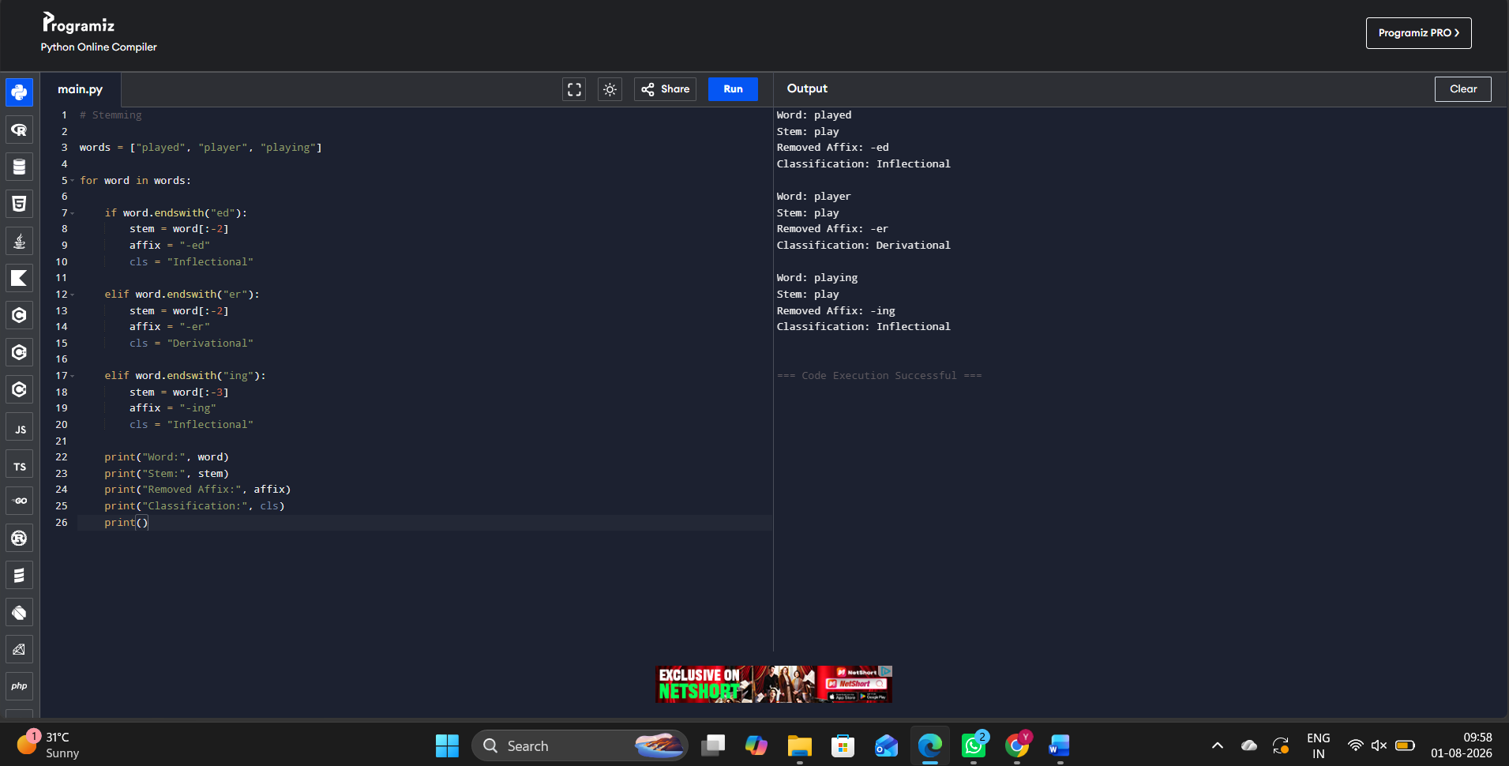

4. Accuracy of Calculation
- Affixes are removed correctly.
- Stem play is consistently obtained.
- Classification accurately distinguishes grammatical and word formation changes.
5. Interpretation of Results
- played and playing are grammatical variations.
- player forms a noun from the verb.
- Common stem play improves search engine retrieval.

Q4. Finite-State Morphological Parsing (writes, writing, written)

1. Problem Understanding
- Analyze writes, writing, written.
- Model state transitions.
- Handle regular and irregular verb forms.
- Normalize to the root.
2. Method Selection
- Finite-State Morphological Parser.
- State transition model.
- Inflection analysis.
- Root normalization.
3. Solution Process
Word | State Transition | Morphological Breakdown | Pattern | Root
writes | write → +s | write + s | Regular Inflection | write
writing | write → drop e → +ing | write → writing | Regular Inflection | write
written | write → irregular → written | write + en | Irregular Inflection | write

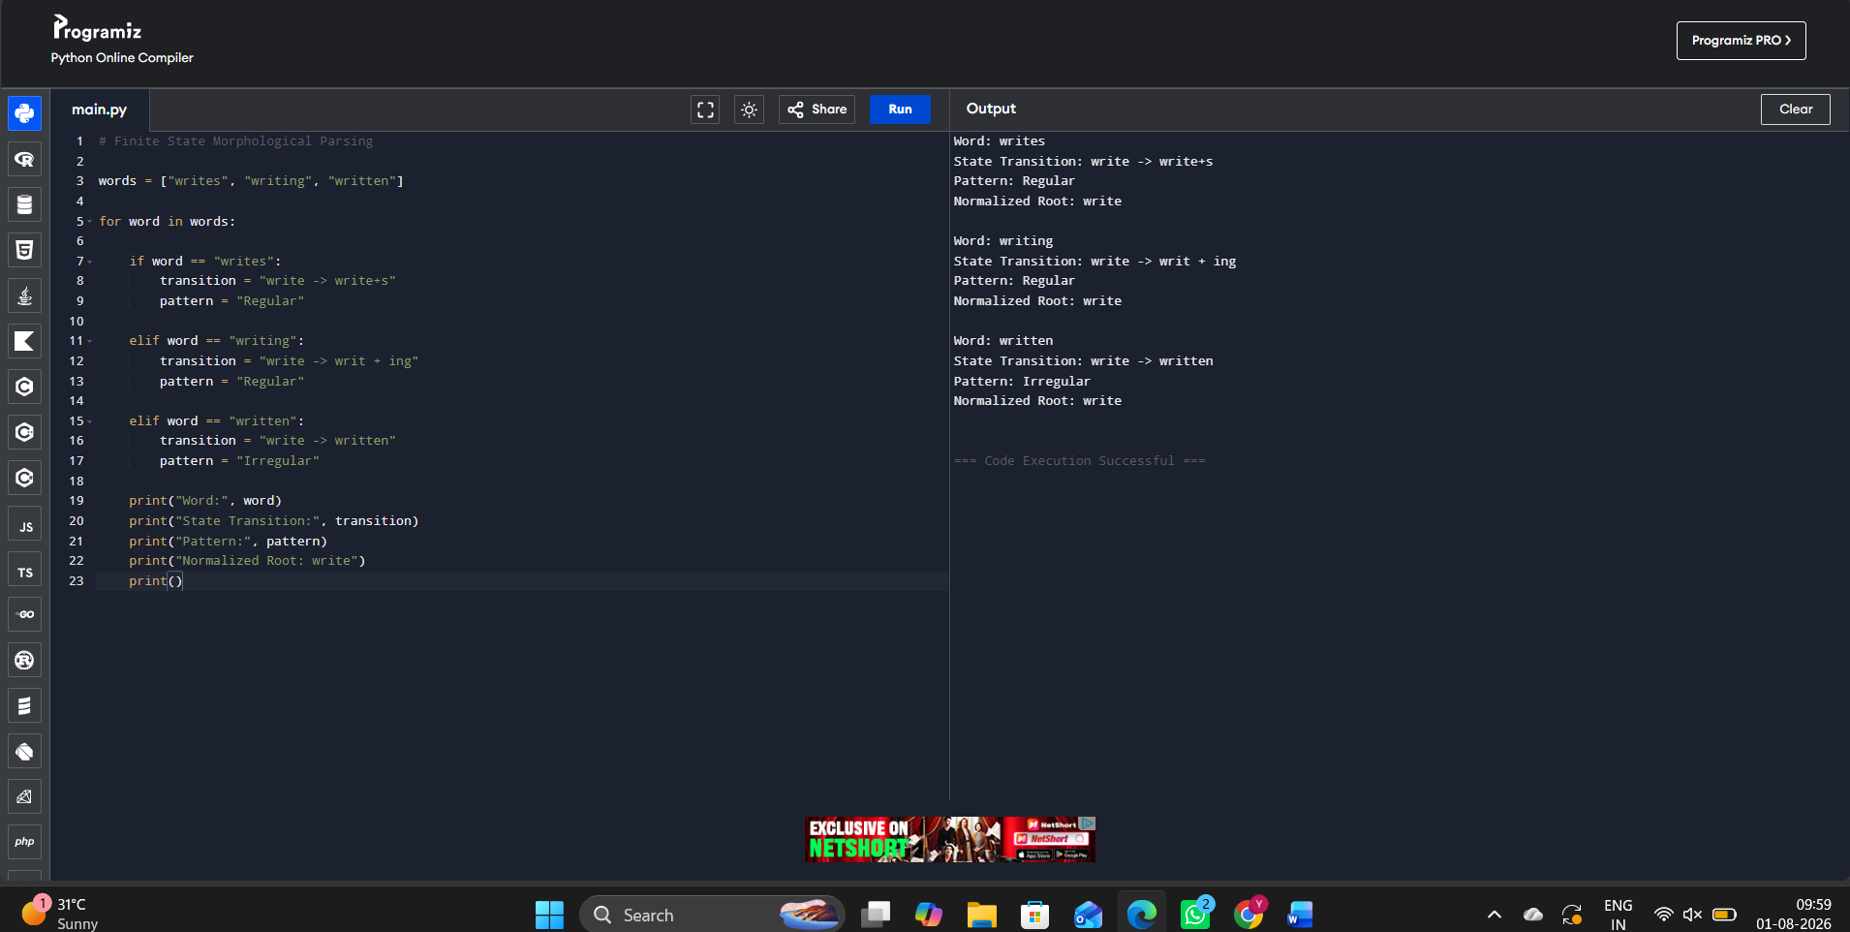

4. Accuracy of Calculation
- State transitions correctly represent suffix changes.
- Regular and irregular forms are distinguished.
- All forms map correctly to the root write.
5. Interpretation of Results
- writes and writing follow regular inflection rules.
- written follows an irregular pattern.
- Normalization to write enables consistent text processing.

Q5. Porter Stemmer (relational, relation, relate)

1. Problem Understanding
- Analyze relational, relation, relate.
- Apply Porter stemming rules.
- Preserve semantic meaning.
- Produce a common stem.
2. Method Selection
- Porter Stemmer algorithm.
- Rule-based suffix removal.
- Intermediate stem generation.
- Final stem extraction.
3. Solution Process
Word | Stemming Step | Intermediate Form | Final Stem
relational | remove -ational → relate | relate | relat
relation | remove -ion | relat | relat
relate | remove -e | relat | relat

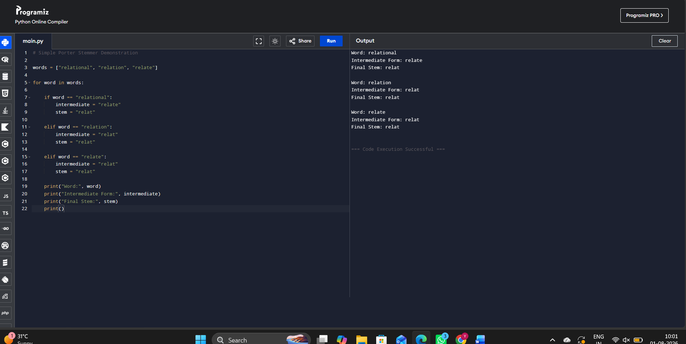

4. Accuracy of Calculation
- Porter stemming rules are applied correctly.
- Intermediate forms are accurately generated.
- Final stem relate is consistent for all words.
5. Interpretation of Results
- Different suffix patterns converge to the common stem relate.
- Semantic similarity is preserved.
- Uniform stemming improves document retrieval and search performance.

